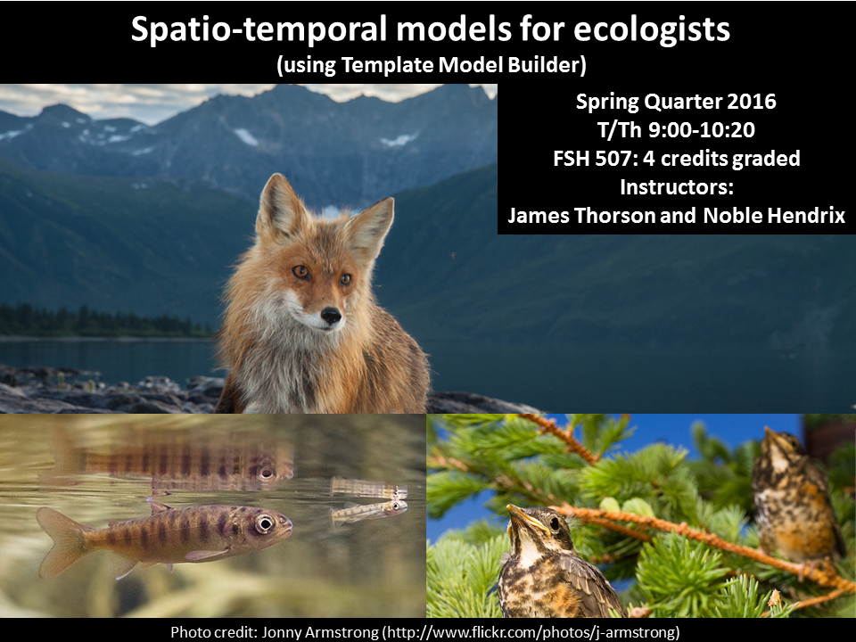

**Spatio-temporal models for ecologists**

**Spring 2016 Schedule**

Tues 9:00-10:20: Lecture

Thurs 9:00-10:20: Computer Lab

**Credit hours:** 4

**Instructors***:*

James Thorson and Noble Hendrix

*Office Hours:*

Jim: Tues. after class

Noble: TBD

**Teaching Assistant**: Jin Gao

**Recommended pre-requisite knowledge**

We recommend the following experience prior to taking this class:

* Introductory knowledge of the R programming language (i.e., knowing how to open the software, save a script, perform basic arithmetic, and write a function)
  + Intro. to R programming (FSH 552), or equivalent experience
* Introductory knowledge to likelihood-based statistics (i.e., how to define a likelihood function, how to use a nonlinear optimizing function)
  + i.e., advanced R course, or 454, 458

**Contacting Instructor**

Please post questions on the GitHub repository, so that answers to all questions can be searched and found by other students:

<https://github.com/James-Thorson/2016_Spatio-temporal_models/issues>

Please only send queries that can be answered by a short message. Questions that require more in-depth responses should be made in person during office hours (see above). The issue tracker will be checked daily, M – F. Generally, expect a response within 24 hours after it is checked.

**Lectures and laboratories**

Tuesday’s lecture is intended to introduce the biological, statistical and sampling theory necessary for a given topic, and will be accompanied by the assignment of a short homework. Thursday’s laboratories are intended to familiarize students with the modelling necessary for completing the four homework assignments.

**Readings**

We don’t currently plan to assign readings, but might change our minds….

**Homework**

Homework is assigned during Thursday labs, and is due at the beginning of the lab on the following week. You are required to write all code individually, even when working with assistance from other students. If collaborating, you are required to re-type all code individually (without using cut-paste, or file copying).

**Final project**

The class will be graded in part based on material related to the final project. This includes:

1. a written description of the work plan in Week 5l
2. a final presentation in Week 10; and
3. a written description of the research due finals week.

The project will require either simulated or real-world application of the methods from the class (or application of the hierarchical approach using other similar methods). Students are encouraged to replicate analyses in the published literature, or find data sets using Dryad (<http://datadryad.org/>) or Ecological Archives (<http://esapubs.org/archive/search.php>).

**Grading**

Your final grade will be based on components related to the class project:

Weekly homeworks in Weeks 1, 2, 3, and 5 (5 points each)

Written description of project topic and approach in Week 5 (5)

Final presentation of project (20 points)

Written description of project (50 points)

The following lists the minimum scores needed to achieve each grade tier.

|  |  |
| --- | --- |
| **Total points** | **Grade** |
| 90+ | 4.0 |
| 80-89 | 3.5 |
| 70-79 | 3.0 |
| 60-69 | 2.5 |
| 50-59 | 2.0 |
| 40-49 | 1.5 |
| 30-39 | 1.0 |
| 20-29 | 0.7 |

s

This will be curved as needed.

Late written assignments are subject to a 1 pt./day penalty and additionally will be assigned no credit after 7 days. Presentations must be done on the day assigned, and cannot be made up. **Holidays and weekend days are NOT excluded from the late penalty assignment**.

**Draft syllabus**

Holidays: Memorial Day (May 30, 2016)

* Week 1 (3/28 – 4/1/16) – Introduction to linear models and likelihood statistics
  + Objectives: Introduction to generalized linear models and TMB
  + Lecture:
    - likelihood function
    - Hessian matrix and estimated standard error
    - nonlinear minimizer
    - response and predictor variables
    - error distribution for response variables
  + Lab:
    - Theory of maximum likelihood estimators (consistency, bias, efficiency)
    - Setting up TMB
    - Comparison of TMB and functions in R for a zero-inflated gamma distribution
  + Homework:
    - Simulation exercise fitting evaluating statistical performance of zero-inflated Poisson GLM in TMB at estimating a covariate
* Week 2 (4/4 – 4/8/16) – Hierarchical models
  + Lecture:
    - Random effects
    - marginal likelihood function
    - Laplace approximation and inner vs. outer optimization
  + Lab:
    - Build a poisson-GLMM
    - Comparison of TMB and *glmer* in R
  + Homework:
    - Code a Poisson-GLMM with repeated measures (i.e., an N-mixture model with site-level heterogeneity) using an example data set
* Week 3 (4/11 – 4/15/16) - Temporal structure and state-space models
  + Lecture
    - White noise and random walk process
    - Autoregressive (AR) structure (equal intervals)
    - Moving average (MA) structure (equal intervals)
    - Optional: cumsum and unit-root (integrated structure)
  + Lab
    - Build a state-space model with autocorrelation in state process
  + Homework
    - Build a simulation exercise to explore the estimation performance of the lab model. Specifically, compile estimates from 100 replicates for 3 values of AR (-0.5,0,0.5) and three levels of measurement error (50% of process error, 100% of process error, 200% of process error)
* Week 4 (4/18 – 4/22/16) – Theory of spatial models
  + Lecture
    - Generalized covariance matrix for state process
    - Semi-variance functions
    - Models for semi-variance
    - Stationarity, isotropy, anisotropy
  + Lab
    - Kriging (using R package TBD)
  + Homework
    - 1-2 page written description of class project listing at a minimum (a) the data set to be used, (b) the question to be addressed, and (c) the statistical analysis required to address this question
* Week 5 (4/25 – 4/29/16) – Spatial analysis in TMB (1-dimension)
  + Lecture
    - Covariance for autocorrelated spatial process with equal distances in 1-dimension
    - Introduce discrete autoregressive and random-walk processes
    - Introduce sparseness of inverse-covariance
    - Role of sparseness in computation
  + Lab
    - Covariance for autocorrelated spatial process with unequal distances in 1-dimension
    - Introduce continuous Wiener and Ornstein-Uhlenbeck process
    - Build Poisson-GLMM for spatial variation with unequal sampling intervals
  + Homework
    - Modify lab code to include a covariate, and compare covariate with and without AR process for an example data set
* Week 6 (5/2 – 5/6/16) – Spatial analysis in TMB (2-dimensions)
  + Lecture
    - Introduce “Species distribution models”
    - 2D AR process on uniform grid
    - Matern process with random locations in 2-dimensions
    - introduce Lindgren SPDE approximation
  + Lab
    - Introduce retransformation bias and bias-correction
    - Discuss “geometric anisotropy”
    - *In-class exercise*: compare different 2D estimates of total abundance for a spatial GLMM
  + Homework
    - 2-4 page written update on project providing at a minimum (a) a graphical summary of the data, (b) a description of how this graphical summary provides qualitative support for the question to be addressed
* Week 7 (5/9 – 5/13/16) – Spatiotemporal models in TMB
  + Lecture
    - Combining spatial and temporal processes
    - Build code for ‘Spatial index standardization’
    - Discuss “advanced” distributions for continuous and discrete sampling data
  + Lab
    - *In-class exercise*: Build spatial Gompertz model using state-space parameterization (Matern spatial and AR temporal process)
  + Homework
    - No homework (work on project!)
* Week 8 (5/16 – 5/20/16) Multivariate models
  + Lecture
    - Introduce covariance among variables, and factor analysis method
    - Introduce spatial factor analysis
  + Lab
    - *In class exercise*: Develop code for spatial factor analysis
  + Homework
    - No homework (work on project!)
* Week 9 (5/23 – 5/27/16) Models for movement
  + Lecture
    - Advection-diffusion operators
    - Discrete approximation and matrix exponential
  + Lab
    - Introduce *MovementTools* package (on github)
    - Modify spatial Gompertz model to incorporate advection-diffusion dynamics
  + Homework
    - Finish presentations (due starting week 9)
* Week 10 (5/30 – 6/3/16) – Final project presentations
  + Homework
    - Finish 6-15 page project write-up (including all figures and tables, due finals week), incorporating at a minimum (a) an introduction, methods, results, and discussion section, (b) a clearly identified question, description of statistical method, and statistical support for answering the question
* Finals week – Finish final presentations